What is diversity in the workplace?

Diversity in the workplace doesn’t just mean that an organisation employs a wide range of diverse individuals from a range of protected characteristics and staff are more representative of the people in the wider community - but that the workforce has a range of people who have had different experiences and backgrounds and that a diverse workplace is inclusive and welcoming to all, making a positive impact in the work we do, regardless of area or sector.
In Jersey people with certain protected characteristics are afforded some protection against discrimination under Jersey Law, (this list does differ from the UK Equality Act - see...) but workplace diversity can go much further than that and there are some areas that are more unique to Jersey, for example in the UK whether you have grown up locally or been from a different area is less important, whereas, migration/housing status and islander v newcomer or contractors temporarily working in Jersey.

Workplace diversity - inclusion fad or a competitive advantage?
Diversity in the workplace has long been one of the hottest topics in the HR industry, but in more recent years, it has become a major goal for many organisations, looked at by shareholders and employees alike.
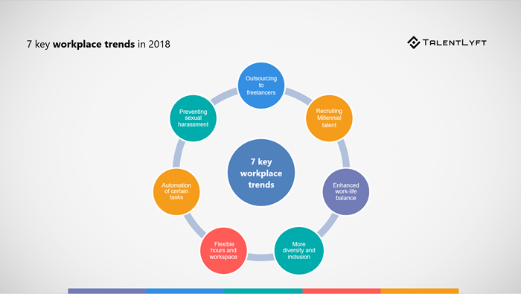
Workplace diversity is now something most organisations strive to achieve. Why is that? Is it just about improving an organisation’s reputation and promoting inclusion at the workplace?
While your organisation’s reputation and workplace inclusion are definitely important goals worth pursuing, workplace diversity has many other immediate and tangible benefits related directly to your organisation’s bottom line.
Workplace diversity is not just a politically correct fad - it is a serious competitive advantage.
Organisation’s with a more diverse workplace outperform competitors and achieve greater profits!

What are the benefits of diversity in the workplace?
Here is the list of the top 10 benefits of diversity in the workplace:
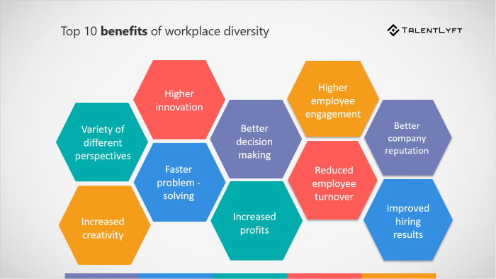

Workplace diversity benefit #1: Variety of different perspectives
Diversity in the workplace ensures a variety of different perspectives.
Since diversity in the workplace means that employees will have different characteristics and backgrounds, they are also more likely to have a variety of different skills and experiences.
Consequently, employees in an organisation with higher workplace diversity will have access to a variety of different perspectives, which is highly beneficial when it comes to planning and executing a business strategy.

Workplace diversity benefit #2: Increased creativity
Diversity in the workplace leads to increased creativity.
People with different backgrounds tend to have different experiences and thus different perspectives. Exposure to a variety of different perspectives and views leads to higher creativity.

Workplace diversity benefit #3: Higher innovation
Diversity in the workplace leads to higher innovation rate.
According to Josh Bersin's research, inclusive organisations are 1.7 times more likely to be innovation leaders in their market.

Workplace diversity benefit #4: Faster problem-solving
Organisations with higher workplace diversity solve problems faster.
Harvard Business Review found diverse teams are able to solve problems faster than cognitively similar people.

Workplace diversity benefit #5: Better decision making
Workplace diversity leads to better decision-making results.
A white paper from the online decision-making platform Cloverpop has found a direct link between workplace diversity and decision-making. Researchers found that when diverse teams made a business decision, they outperformed individual decision-makers up to 87% of the time.

Workplace diversity benefit #6: Increased profits
Organisations with greater workplace diversity achieve greater profits.
McKinsey & Company, a global management consulting firm, conducted research that included 180 organisations in France, Germany, the United Kingdom, and the United States. They found out that organisations with more diverse top teams were also top financial performers.

Workplace diversity benefit #7: Higher employee engagement
Workplace diversity leads to higher employee engagement.
Deloitte conducted research that captured the views and experiences of 1,550 employees in three large Australian businesses operating in manufacturing, retail and healthcare. This research showed that engagement is an outcome of diversity and inclusion.

Workplace diversity benefit #8: Reduced employee turnover
Workplace diversity is beneficial for employee retention.
Organisations with a diverse workforce are generally more inclusive of different individual characteristics and perspectives.
Diversity and inclusion in the workplace cause all employees to feel accepted and valued. When employees feel accepted and valued, they are also happier in their workplace and stay longer with an organisation. As a result, organisations with greater diversity in the workplace have lower turnover rates.

Workplace diversity benefit #9: Better organisation reputation
Workplace diversity boosts the organisation’s reputation and brand.
Organisations that are dedicated to building and promoting diversity in the workplace are seen as good, more human and socially responsible organizations.

Workplace diversity benefit #10: Improved hiring results
Workplace diversity leads to better hiring results.
Diversity in the workplace boosts an organisations employer brand and presents an organisation as a more desirable place to work. Workplace diversity is an especially beneficial asset for attracting top talent from diverse talent pools.
According to a survey conducted by Glassdoor, 67% of job seekers said a diverse workforce is important when considering job offers.

